

HEADCORN HEADLINES: Friday, 5 July 2024
Dear Parents and Carers

We have had a fun Science Day today with the school community working on making a junk model boat to float in a paddling pool. The designs have been so varied and results exciting. We hope to share some photos in next week’s Headlines!
Thank you to everyone who was able to attend Meet the NEW Teacher yesterday with their child. We had a really positive Transition Day with so many smiles and excitement about next year.
As last year, early in Term 1 we will be holding Year Group meetings where you can meet the teachers, learn about expectations, the curriculum, trips, events for this new academic year. Dates to be confirmed soon.
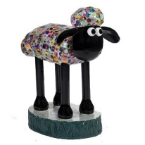
Shaun the Sheep: Our very own Cupcake Shaun the sheep is on display. She’s at Clinton Cards in Fremlin Walk. If you visit take a selfie with her and send it to birthdayevent@headcorn.kent.sch.uk We are doing a display of everyone finding her! See below for more information on the Shaun the Sheep trail available.

Have a lovely weekend!

Miss Symonds

Dates for your Diary:
Thursday 11th July: Year 1 Trip to Kent Life
Friday 12th July: Year R Trip to Rare Breeds
Mon 15th - Tue 16th July: Y6 Kench Hill Residential
Fri 19th July – End of Year Discos (YR/1/2 during school day, Y3/4 5-6pm & Y5/6 6.30 – 7.30pm)
Tuesday 23rd July: End of Term 6 / End of Year

Monday 2nd September: INSET Day 1 – No children in school
Tuesday 3rd September: Children back to school

Wednesday 23rd October: End of Term 1
Thursday 24th October: INSET Day 2 – No children in school
Friday 24th October: INSET Day 3 – No children in school

NB These dates are also available on the calendar on our website: www.headcorn.kent.sch.uk

Assemblies
Every day the children have assemblies that are aimed at developing their understanding of the wider world, sharing our Core Values, and encouraging self-reflection.
Next week's assemblies will focus on our core value of inclusion, celebrating the unique qualities and differences that make each of us special. Through thoughtful assemblies, students will learn the importance of embracing diversity and fostering a welcoming community where everyone feels valued and respected.
Music of the Week

Each week, we're inviting members of our school staff to share their favourite songs and music with the children during assembly time. This week we have another Bowie choice from Mr Drury. The Laughing Gnome. Want to hear it at home? https://www.youtube.com/watch?v=5SQdBxVjZx4

PE & Earrings
For students who wear earrings, it is crucial to either remove them or properly tape them before participating in any physical activities. Lately, we have noticed a growing number of children who are not adhering to these safety requirements during PE.

Here are the key points to remember:
Remove Earrings: If possible, please have your child remove their earrings before PE sessions to completely eliminate the risk of injury.
Taping Earrings: If removal is not an
option, please ensure that the earrings are securely taped. The tape should be of significant thickness to adequately protect the earlobe from potential damage caused by collisions or falls.
Proper Tape Usage: Use a substantial amount of hypoallergenic tape to cover the earrings entirely. This will provide a protective barrier and reduce the risk of the earrings catching on clothing, equipment, or other students.

By taking these precautions, we can help ensure that all students remain safe and injury-free during their physical education activities. Your cooperation and attention to this matter are greatly appreciated.
Thank you for your support.

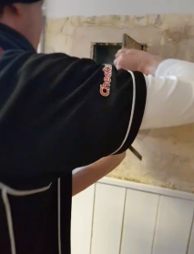
150th Birthday
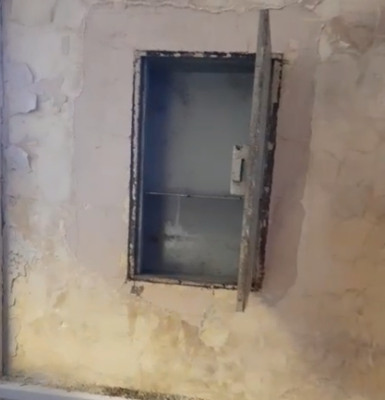
In the old Headteacher’s office there lies a secret….behind a simple picture frame there is a safe! There is no key and nobody remembers it ever being opened !!! After many hours of work, specialist tools and a little brute force, the safe was opened and found to be empty…
But that is not the end of the story.

This safe will now become a home for all our memories of celebrating our birthday. Pictures from our tea party with ex pupils, our whole school, the children who entered our creative competitions, our new library (when it is built) and from our tree planting. Not to mention lots from Cupcake.
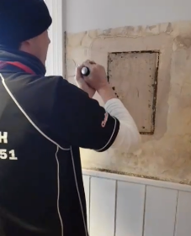

We owe a big thank you to ‘A Short Locksmith’ and his team. They have tirelessly worked on our safe, tackling numerous challenges, and have consistently come to our aid with a smile and boundless enthusiasm. Thank you for your dedication and hard work!

Shaun the Sheep
Some of our parents and children went to a Shaun the Sheep workshop in Maidstone as a celebration of the trail being up and working. They had an amazing time and represented Headcorn with style.

Plus, our Shaun the sheep is on display. She’s at Clinton Cards in Fremlin Walk. If you visit take a selfie with her and send it to birthdayevent@headcorn.kent.sch.uk We are doing a display of everyone finding her….

Can you find all 109 Shauns? Download the App (Shaun Heart of Kent) and start searching now! There is still time to donate at https://www.justgiving.com/page/headcorn-school-1702295401506?utm_medium=fundraising&utm_content=page%2Fheadcorn-school-1702295401506&utm_source=copyLink&utm_campaign=pfp-share

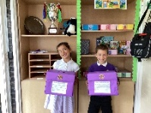
School Council
The School Council have introduced suggestion boxes to make sure that every pupil's voice is heard! Make sure to share your ideas or suggestions and the School Council will read them before their meetings.

Snapchat Introduces Enhanced Safety Features to Protect Users

To bolster user safety and privacy, Snapchat has rolled out a series of new updates aimed at curbing unwanted interactions and improving user control over their connections. The social media platform, which is especially popular among younger audiences, has long been under scrutiny to enhance its safety measures. As of the end of June, Snapchat has introduced several new features to ensure a safer and more secure environment for its users. Here’s a closer look at these enhancements and how they work to protect you.

Blocking and Friend Requests from Bad Actors
One of the most significant updates addresses a common loophole used by malicious actors. Previously, users who blocked an account might still receive friend requests from new accounts created by the same person using the same device. The latest update aims to close this loophole. Snapchat now has the capability to identify and block friend requests sent from different accounts on the same device, provided those accounts have already been blocked by the user. This means if you block someone, you won't receive friend requests from any new accounts they create using the same device.

Enhanced Location Sharing Awareness
Snap Maps, Snapchat’s location-sharing feature, has also received a safety-focused update. Users will now receive more frequent reminders about who they are sharing their location with. This is particularly important for maintaining privacy and ensuring that users are constantly aware of their location-sharing settings. The reminders aim to prompt users to regularly review and, if necessary, update their settings to ensure they are comfortable with the audience they are sharing their location with.

Improved Friend Request Warnings
Snapchat has also enhanced its safeguards around adding new friends. Now, if a user attempts to add someone who does not share mutual friends or is not in their contacts, they will receive a more prominent pop-up warning. This warning serves as a precautionary measure, encouraging users to think twice before accepting or sending friend requests to strangers. This feature aims to reduce the risk of connecting with potentially harmful individuals.

Why These Updates Matter
These updates are crucial in a digital age where online safety is paramount. With increasing reports of cyberbullying, harassment, and other online threats, these new measures by Snapchat represent a proactive approach to protecting its users. By limiting the ability of blocked individuals to reconnect through new accounts, enhancing location-sharing awareness, and cautioning users about friend requests from strangers, Snapchat is taking significant steps to create a safer online community.

Tips for Staying Safe on Snapchat
While these updates are a positive move, users should continue to practice general online safety measures:
- Be cautious about who you add: Always review friend requests carefully and avoid adding strangers.
- Regularly check your privacy settings: Make sure your settings reflect your current comfort level with sharing personal information.
- Use the block and report features: If someone is making you uncomfortable or violating Snapchat’s guidelines, use the blocking and reporting features immediately.
- Stay informed: Keep up with the latest updates and features from Snapchat to make the most of the platform’s safety tools.
Snapchat’s latest updates are a reminder of the platform’s commitment to user safety. By staying informed and utilizing these new features, users can enjoy a safer and more secure experience on the app.
For more information on these updates, you can read the full article on TechCrunch here.

St Peter and St Paul’s Church
Sunday, 7 July: Children are welcome to come and climb the steps up to the top of the church tower, but must be accompanied by an adult, and with the air show going on overhead on Sunday the views will be the best in the village!
Sunday, 7 July: Café Church 9.30am to 10.30am
Saturday, 20 July: Fiona’s leaving concert
Please see attached flyers for more information

PTFA News
- End of year discos will be held on Friday 19th July. Years R, 1 and 2 will be during school and Years 3,4,5,6 will be after. Watch out for more info on this in your emails very soon.
- Please can we keep the branded uniform donations coming. Something you do not need anymore will really benefit another family whilst raising money for the school.

Next Week’s Curriculum Overview
   | Year R Cheetah and Leopard Classes: Next Week’s Curriculum Focus  Maths: This week’s focus is on assessing and deepening the children’s developing automaticity with some number facts.  Literacy: Using descriptive language to write about the wonders of water!  Topic: Making boats using a range of media.  RWI Links  Miss Ferguson’s Group Learning to blend  Miss Cresswell’s Group The sound r  Miss Gelder’s Group Spelling using air, Spelling using ir  Mrs Day’s Group Reading using a-e, Reading using i-e  Miss Young’s Group Reading using i-e, Reading using o-e  Mrs Griffiths’ Group Reading using ur, Reading using er
  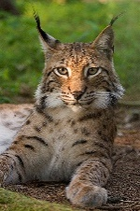 | Year 1 Tiger & Lynx Classes: Next Week’s Curriculum Focus  English: We will be using our plan from last week to write our final discussion piece - answering the question 'Should all buildings have a rooftop garden?'  Maths: We will be learning the days of the week, months of the year and the difference between seconds, minutes and hours.  History: We have our school trip to Kent Life on Thursday! We will be taking part in a Victorian Schools workshop.  PSHE: We will be thinking about the changes that have happened in our lives and know some ways to cope with changes.  RWI Links: Please use the following links to recap sounds that your child has learnt in their phonics group this week.  Miss England and Mrs Tucker's Group: the sound 'au', the sound 'e-e', the sound 'ue'  Mrs Baldock's Group: the sound 'ur', the sound 'er', the sound 'ow'  Miss Arthur's Group: the sound 'are', the sound 'ur', the sound 'er'
  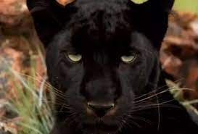 | Year 2 Puma & Panther Classes: Next Week’s Curriculum Focus  English: Reading comprehension and continuing to read our whole class text 'Olga Da Polga.'  Maths: Consolidating our learning on position, direction and addition and subtraction.  RWI Links: Please watch the video clips from your child's RWI group:  Miss Ferguson's group: blending, b sound, u sound  Mrs Baldock's group: ir sound and ou sound  Miss Arthur's Group: the sound 'are', the sound 'ur', the sound 'er'  Miss Harman and Miss Stanton's group: longer words  Other: Completing our bag tags in design technology.
   | Year 3 Jaguar & Pallas Cat Classes: Next Week’s Curriculum Focus  English: We will start to plan our own time travel story, inspired by ‘The Leopard in the Golden Cage’. Which famous Roman sites will we choose for our adventures?  History: We will discover why the Romans decided to leave Britannia.  Mrs Batt’s Recommended Reads:  ‘Furry Purry Beancat- The Railway Cat’ by Philip Ardagh  ‘The Day I Fell Into a Fairytale’ by Ben Miller
  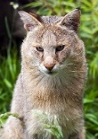 | Year 4 Jungle Cat & Cougar Classes: Next Week’s Curriculum Focus  Maths: We are describing position using co-ordinates and plotting co-ordinates to create shapes.  English: We are beginning to write a newspaper all about Year 4 to inform the pupils moving up from Year 3.  Other: In History we are looking at the decline and decay of ancient civilisations. In PSHE/RE: we are ‘Looking Head,’ reflecting on the changes that we can make next year and how we will go about these.  PLEASE CAN WE ASK THAT THE CHILDREN BRING IN ANY JUNK MODELLING FOR OUR DT PROJECT
   | Year 5 Caracal & Snow Leopard Classes: Next Week’s Curriculum Focus  Maths: we will be looking at our last topic; measurement.  English: we will be writing some instructions based on our boat building in science.  Science: we will be looking at different stages in the human life cycle in greater detail.
   | Year 6 Lion & Ocelot Classes: Next Week’s Curriculum Focus  Welcome back Year 6! We hope you all had a great time at your secondary schools.  Science week! We will be exploring light theory through lots of practical investigations to identify how light travels, understanding how we see objects and perceive colour and measuring light with light meters.

