Year 2’s Home Learning AMAZING HABITATS Spring 1
Our topic this term is ‘Amazing Habitats!’ Please could your child/children try to complete at least one task during the term and before February half term.
If you have other ideas we will be very excited to share these too. The most important thing is that the children have fun completing it/them.
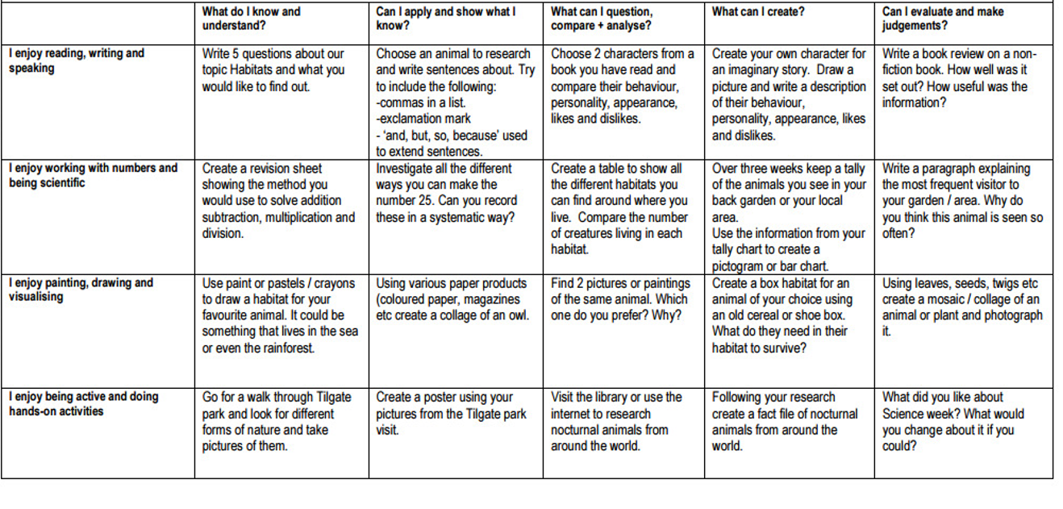
Each week your child will be given spellings to learn. They will be tested every Friday. The children will also be given 1 or 2 Mathletics tasks a week (usually just a 10 question activity) – if they have trouble completing them at home they can use school time to complete it, if they let us know.
The children will also be given a times table to learn and practise at home.
