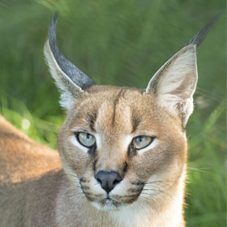
Caracal Home Learning
Home learning is collected on a MONDAY.
Please always make sure you include your name so we can celebrate all your hard work.
Spelling tests are also on a MONDAY and for this term will be set on a WEDNESDAY.

Spellings –
This term, spellings will be organised a little differently. Rather than set lists, children will be allocated spellings based on errors made during in-class assessments. This will aid the children’s spelling in class, and revise key high frequency words. Spellings will therefore be given out on a Wednesday for a Monday test. Please check contact book for the given spellings each week. Those children in spelling groups will continue to be aided in school.

Mathlectics – Times Table Rockstars
Each week you should aim to earn 1000 points in Mathlectics and spend some time on Times table Rockstars to improve your speed and accuracy with your tables.
If you have problems accessing a computer, time is available at break times upon request. Or if you are finding the work challenging please let me know and I can help.

Other –
Overleaf is the home learning for the term including due dates. If you are unsure about what is expected please feel free to ask.

Home learning is not intended to be a chore but an opportunity to practise skills and reinforce learning in class. As such it will be stuck into your class books and so the quality of the work should match that which you do in school. If you need resources please ask and remember to check you are prepared for the work in advance of the due date.

Work can be handed in at any point during the week before the due date. This saves the stress of forgetting it the morning it is due.

Unfortunately if home learning is not handed in or is late, a break time will be used to complete the work to avoid missing the learning.

Term 2

Due | Other
4th Nov | Diary entry – English  Last week we explored how to write diary entries.. I would like you to have a go at writing a diary entry or two at home. This can be written as yourself or as a character from a book. Think about how to include emotions, first person viewpoint and interesting events. (If you are writing about yourself remember not to include anything that might upset others). I am looking forward to reading your results. Your work may be typed or handwritten.
11th Nov | Research – History  The 11th November will be the Anniversary of the end of WW1.  Look around and record memorials that you find which commemorate people that have died during this conflict. Take photos or draw pictures and note down what is written and where the memorial is located. It may be plaques, war memorials, gravestones ect…  Make sure your work is presented carefully on paper no bigger than A3.
18th Nov | Antarctic picture - Art  Create an image showing what the Antarctic is like. You may want to include what lives there or an image of the landscape. You may use any medium you wish such as paint, pencil, crayon, collage…….  It must be no bigger than one side of A3.  Let your imagination take over…
25th Nov | Water cycle – Geography  Create a way to show the water cycle. This could be a poster, a model, booklet or whatever takes your fancy. It must show the water cycle with diagrams and correct vocabulary. Please not too big….  There is a handy clip at https://www.bbc.co.uk/education/clips/z8qtfg8
2nd Dec | Materials activity – Science  Choose at least two objects from around your home. Draw a picture of it and label the different materials it is made from. Identify the properties these materials have and why they were chosen to make the object.  Eg. Frying Pan  Metal  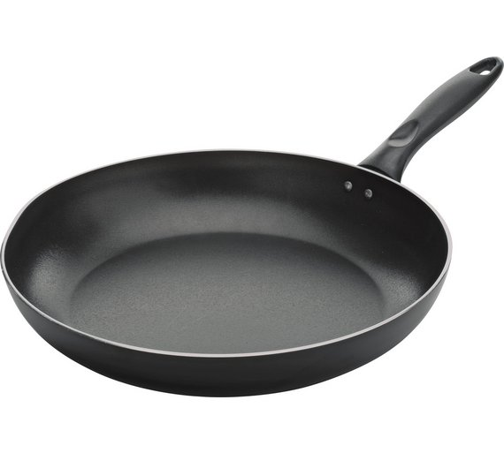  Metal to conduct heat from the hob and allow the food in the pan to heat up and cook.  Plastic  Plastic to insulate against the heat, so you can hold the pan without getting burnt.
9th Dec | Information Page – English.  We have been looking at Ernest Shackleton and how he is a hero to many for his bravery, courage and determination. Think about someone who you think is a hero and create an information page about him or her. It could be someone from the past or alive now, it may be someone famous or someone in your family.  Remember to include a clear title, facts, a paragraph of information (What makes them a hero?) and appropriate illustrations. Think carefully about how to make your page informative and beautifully presented. One side of A4 or A3 please.
16th Dec | No Home-learning this week.

