Jaguar Class Ancient Egypt Homework Grid Please choose two pieces of Home Learning to complete during the course
of the term. Spelling tests and maths quizzes will take place weekly. I look forward to seeing your wonderful creations!

Weekly Tasks
Reading  Read alongside an adult, be read to by an adult or read independently. Regular short bursts makes a real difference, record your reading in your blue contact book. Each time you finish a book you will receive a sticker for your Book Mark which will lead to prizes. | Spellings  Weekly lists will be sent home on Wednesday to learn for the following Wednesday. | Times Tables & Mathletics  There will be a multiplication facts quiz each Monday. In addition, Mathletics activities will be set each week. Can you earn 1000 points each week?
Home Learning | This term we are looking at Ancient Egypt in history. Here are some ideas for Home learning…. | These are suggested ideas, if your child thinks of something different to do then have a go. Most importantly—have fun!
Write an acrostic poem using the letters of a key Egyptian word. You could choose a word like: Mummy, Egypt, Nile, Pyramid etc.  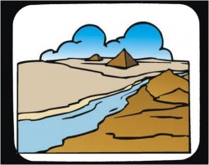  N...  I...  L...  E... | 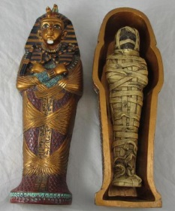  Make an Egyptian Mummy with its own tomb or coffin. Remember they are  decorated to show off  their wealth. | Use hieroglyphs to write a message to a friend or family member. Can they crack your Egyptian code?  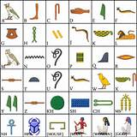
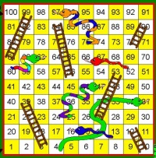  Make a simple game about  Ancient Egypt e.g. snap, uno,  snakes and ladders etc. | Create a fact file about ancient  Egypt. Think about the river  Nile, the Pyramids, the gods,  food and drink, their clothing and the houses. | 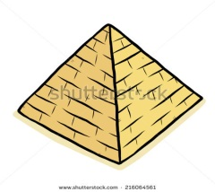  Design and make your own  pyramid. What materials  will you use to construct it?

