Learning Skill:

**‘Becoming Better Learners’**

*(Improving Own Learning and Performance)*

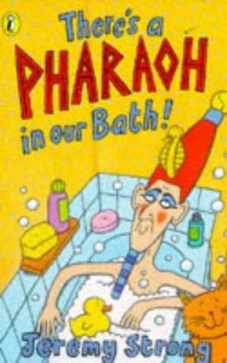



Egyptian Banquet!

**3**

Art and D.T.

Create art based upon the period.

Examine tomb paintings and explore how they have helped historians to understand the past.

Egyptian cooking.

History

A study of the way people lived in Ancient Egyptian. In particular focusing on their beliefs and exploring their greatest inventions.

Science

Forces and Magnets Comparing how pyramid builders moved blocks of stone on different surfaces.

To observe how magnets attract and repel each

Maths

Place value- including ordering and comparing 3-digi numbers. Doubling and Halving numbers to 40.

Multiplication and division facts for 2, 5, 10, 3 and 4 times tables.

English

Our book this term is There’s a Pharaoh in our Bath.

Writing in a variety of formats including: instructions and news reports.

Editing and improving work considering handwritings and punctuation.

Would you want to live in Ancient Egypt?